**CSS & CSS3**

**Q1.** **What are the benefits of using CSS?**

**Ans.**

**Consistency** : CSS allows you to define styles centrally, ensuring that all elements on a website look consistent.

**Separation of concers:** With CSS, you can separate the content of your website from its design. This makes it easier to update and maintain both aspects independently.

**Flexibility:** CSS provides a wide range of styling options, allowing you to customize the appearance of elements to suit your needs.

**Efficiency:** By applying styles across multiple pages, CSS helps reduce the amount of code needed, leading to faster load times and easier maintenance.

**Accessibility:** CSS allows you to improve the accessibility of your website by providing options for better contrast, font sizes, and other design elements that aid users with disabilities.

**Responsive Design:** CSS supports responsive design, enabling your website to adapt to different screen sizes and devices, providing a better user experience.

**Q2. What are the disadvantages of CSS?**

**Ans.**

**Browser Compatibility:** CSS might not always render the same across different web browsers, causing inconsistencies in how a webpage looks.

**Complexity:** CSS can become complex, especially in larger projects, making it challenging to manage and debug.

**Limited Layout Control:** Compared to some other styling methods, CSS has limitations in controlling complex layouts, which can sometimes require workarounds or compromises.

**Perfomance Impact:** Overly complex or inefficient CSS can affect page loading times and performance.

**Global Scope:** CSS operates globally, meaning styles applied can unintentionally affect other elements on a webpage if not carefully managed.

**Learning Curve:** Understanding CSS thoroughly and mastering its various features can take time and effort, especially for beginners.

**Q3. What is the difference between CSS2 and CSS3?**

**Ans.**

**Release Time:**

CSS2: Published in 1998.

CSS3: Introduced as a modularized version, with modules evolving over time. Different modules have different release dates, starting around the late 2000s.

**Modules:**

CSS2: A monolithic specification with a single large document.

CSS3: Introduced a modular approach, with different modules addressing specific features like animations, transitions, and responsive design.

**New Features:**

CSS2: Laid the foundation for basic styling properties and features.

CSS3: Introduces a wide range of new features, including rounded corners, gradients, animations, and more advanced layout options.

**Browser Support:**

CSS2: Widely supported by all major browsers.

CSS3: Support for individual features varies across browsers, and vendor prefixes were initially used for experimental features.

**Development Approach:**

CSS2: Focused on basic styling and layout.

CSS3: Emphasizes more advanced and modern design capabilities, including animations, transitions, and 3D transformations.

**Media Queries:**

CSS2: Did not have Media Queries.

CSS3: Introduced Media Queries, enabling responsive design by allowing styles to be applied based on characteristics of the device or viewport.

**Selectors:**

CSS2: Basic selectors.

CSS3: Introduces more complex and powerful selectors, allowing for more precise targeting of elements.

**Q4. Name a few CSS style components.**

**Ans.**

1. **Selectors:** These define which elements in the HTML document the styles should be applied to. Selectors can target elements by type, class, ID, attribute, or relationship with other elements.
2. **Properties:** These define the visual appearance of the selected elements. Properties include things like color, font-size, margin, padding, etc.
3. **Properties:** These define the visual appearance of the selected elements. Properties include things like color, font-size, margin, padding, etc.
4. **Classes and IDs:** These are used in selectors to target specific HTML elements.
5. **Box Model:** The box model is a fundamental concept in CSS that defines the layout of elements. It consists of content, padding, border, and margin.
6. **Flexbox and Grid:** These are layout models that allow for more complex and responsive designs.

**Q5. What do you understand by CSS opacity?**

**Ans.**

The CSS opacity property is used to specify the transparency of an element. In simple word, you can say that it specifies the clarity of the image.

In technical terms, Opacity is defined as degree in which light is allowed to travel through an object.

opacity applies to the element as a whole, including its contents, even though the value is not inherited by child elements. Thus, the element and its children all have the same opacity relative to the element's background, even if they have different opacities relative to one another.

**Q6. How can the background color of an element be changed?**

**Ans.**

* To add background color in HTML, use the CSS background-color property.
* Set it to the color name or code you want and place it inside a style attribute.
* Then add this style attribute to an HTML element, like a table, heading, div, or span tag.

**Ex.**

.myElement {

background-color: #3498db;

}

**Q7. How can image repetition of the backup be controlled?**

**Ans.**

* This task can be achieved by using the background-repeat property that will help us to control the repetition of the image. The background-repeat property in CSS is used to repeat the background image both horizontally and vertically. It also decides whether the background image will be repeated or not.
* we will make use of the repeat-x to repeat the image in the horizontal direction.
* we will make use of the repeat-y to repeat the image in the vertical direction.

**Syntax:**

{

background-repeat:repeat| repeat-x | repeat-y | no-repeat;

}

**Q8. What is the use of the background-position property?**

**Ans.**

The background-position property sets the starting position of a background image.

By default, a background-image is placed at the top-left corner of an element, and repeated both vertically and horizontally.

The background-position property can take various values, specifying the horizontal and vertical positions. The values can be expressed in pixels, percentages, or keywords.

the background-image property sets the image that you want to use as the background, and background-position: center center; centers the background image both horizontally and vertically within the element.

Here are some common values for the background-position property:

**center**: Centers the background image.

top, bottom, left, right: Aligns the background image to the respective edge.

**Length Values:**

You can use pixel values (e.g., 10px, 20px) to specify the position.

**Percentage Values:**

You can use percentage values (e.g., 50% 25%) to specify the position as a percentage of the background area.

**Q9. Which property controls the image scroll in the background?**

**Ans.**

he backgroundattachment property sets or returns whether a background image should scroll with the content, or be fixed.

scroll: The default value. The background image scrolls with the content.

fixed: The background image remains fixed in the viewport as the content scrolls. It doesn't move with the scrolling of the page.

**Q10. Why should background and color be used as separate properties?**

**Ans.**

* It enhances the legibility of style sheets. The background property is a complex property in CSS, and if it is combined with color, the complexity will further increase.
* Color is an inherited property while the background is not. So this can make confusion further.

**Q11. How to center block elements using CSS1?**

**Ans.**

* To center block elements using CSS1, we can use the margin property.
* We need to set the values of margin-left and margin-right to auto and width to some explicit value.
* This will center the block-level element 1
* Alternatively, we can use the shorthand margin property to center the block element horizontally.

**Q12. How to maintain the CSS specifications?**

**Ans.**

* The CSS specifications are maintained by the CSS Working Group (CSS WG) of the World Wide Web Consortium (W3C) . The CSS WG is responsible for developing and maintaining the CSS specifications, which define how web browsers should interpret and display CSS code .
* To maintain the CSS specifications, the CSS WG follows a standardization process that involves several stages, including Working Drafts, Candidate Recommendations, and Proposed Recommendations . During each stage, the CSS WG solicits feedback from the public and other stakeholders to ensure that the specifications are accurate, complete, and useful .
* If you are interested in contributing to the development of CSS specifications, you can visit the CSS WG’s website to learn more about the current work and how to give feedback . Additionally, you can read the CSS Design Principles to understand the philosophy behind the development of CSS .

**Q13. What are the ways to integrate CSS as a web page?**

**Ans.**

**Inline CSS:** You can add CSS rules directly to an HTML element using the style attribute.

**Ex.**,

<p style="color: red;">This is a red paragraph.</p>

**Internal CSS:** You can define CSS rules in the head section of an HTML document using the <style> tag.

**Ex.**,

<head>

<style>p {color: red;}</style>

</head>

**External CSS:** You can define CSS rules in a separate file and link it to the HTML document using the <link> tag.

**Ex.**,

<head>

<link rel="stylesheet" type="text/css" href="styles.css">

</head>

**Q14. What is embedded style sheets?**

**Ans.**

* Embedded stylesheets, also known as internal stylesheets, involve placing the CSS styles directly within the HTML document.
* This is done using the <style> element within the <head> section of an HTML document.
* The styles specified within the <style> tags apply to the elements within that particular HTML document.
* Embedded style sheets are particularly useful for HTML documents that have unique style requirements from the rest of the documents in your project.

**Q15.**What are the external style sheets?

**Ans.**

* External style sheets are a way to define styles for an entire website in one place.
* This is done by creating a separate CSS file that contains all the styles that need to be used on a website.
* With an external style sheet, you can change the look of an entire website by changing just one file.
* Each HTML page must include a reference to the external style sheet file inside the <link> element, inside the head section.

**Q16. What are the advantages and disadvantages of using external style sheets?**

**Ans.**

* external style sheets are a great way to maintain a consistent look and feel across multiple web pages.
* However, it’s important to consider the potential downsides before deciding to use them.

**Advantages:**

* Improved maintainability and code organization.
* Enhanced reusability across multiple HTML files.
* Efficient caching and faster page load times.

**Disadvantages:**

* Pages may not render correctly until the external CSS is loaded.
* Uploading or linking to multiple CSS files may increase your site’s download time, affecting its overall performance.
* Large-scale projects may face versioning and caching challenges when using external CSS.

**Q17.** **What is the meaning of the CSS selector?**

**Ans.**

* a selector is a pattern used to select and style one or more HTML elements.
* Selectors target specific elements on a web page, and the associated style rules define how those elements should be presented or formatted.
* The combination of selectors and style rules is what allows developers to control the visual presentation of a web page.

**Q18. What are the media types allowed by CSS?**

**Ans.**

* CSS allows you to define different style rules for different media types.
* They allow you to specify different style rules for different output devices or presentations.

Here are some of the common media types allowed by CSS:

**All :** The default media type. It applies to all devices.

**Print :** Intended for paged material and for documents viewed on a print preview screen.

**Screen :** Intended primarily for color computer screens.

**Speech :** Intended for speech synthesizers.

**Q19. What is the rule set?**

**Ans.**

* A CSS rule set is a collection of rules that define how HTML elements should be displayed.
* It consists of a selector and a declaration block.
* The selector points to the HTML element you want to style, while the declaration block contains one or more declarations separated by semicolons.
* Each declaration includes a CSS property name and a value, separated by a colon.
* Multiple CSS declarations are separated with semicolons, and declaration blocks are surrounded by curly braces.

**Q20. Create Layout**

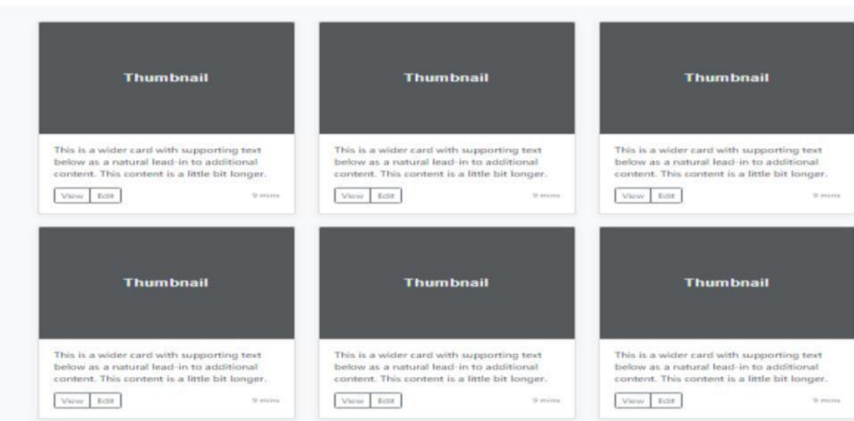

**Ans:**

**For Code:**

**https://github.com/MohitGosai111/GIT-Mohit/tree/main/Assignment/Wd-Css**